
Newsletter September 2011

Dear Madam / Sir,

This is the First newsletter of the Asia Care Foundation. This foundation was founded in the summer of 2010 to support the work of Bob van Rijn in Asia.

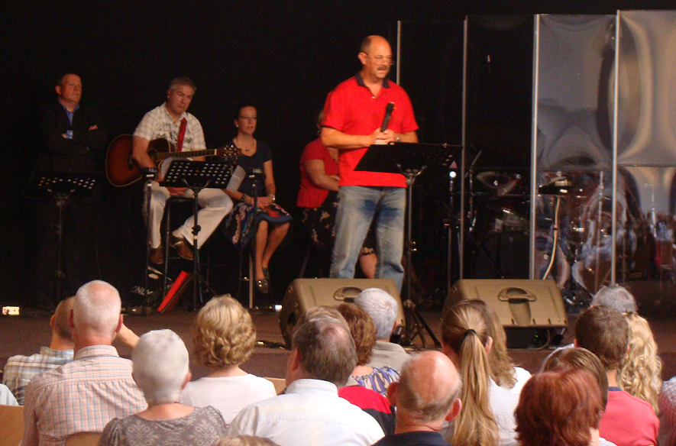
Departure of Bob

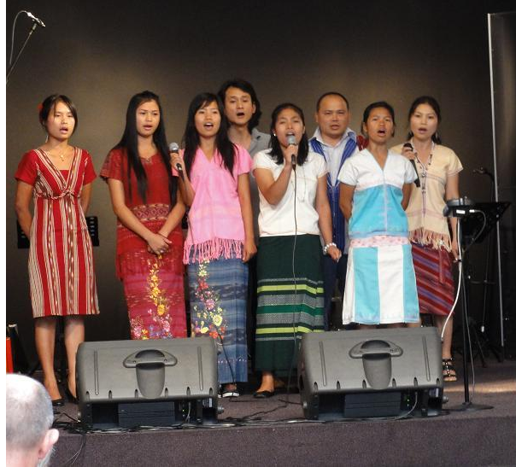
On Sunday, August 22, 2010, Bob was sent away with a blessing from the Evangelical Mission Church `The Ark’. It was a special service where many family members and friends of Bob were present.

Various Karen refugees from Burma attended the service with a song in their own language.

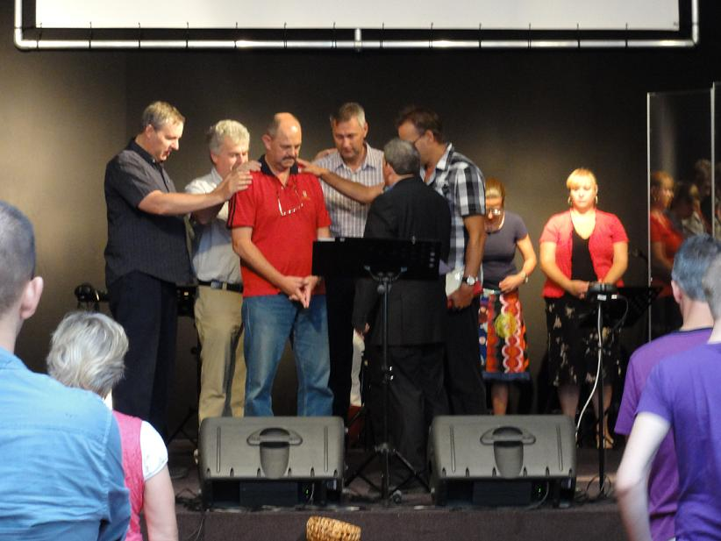
After the service Bob gave a farewell party in his former home for his

family and the present Karen refugees. The Friday thereafter Bob went to Thailand by airplane.

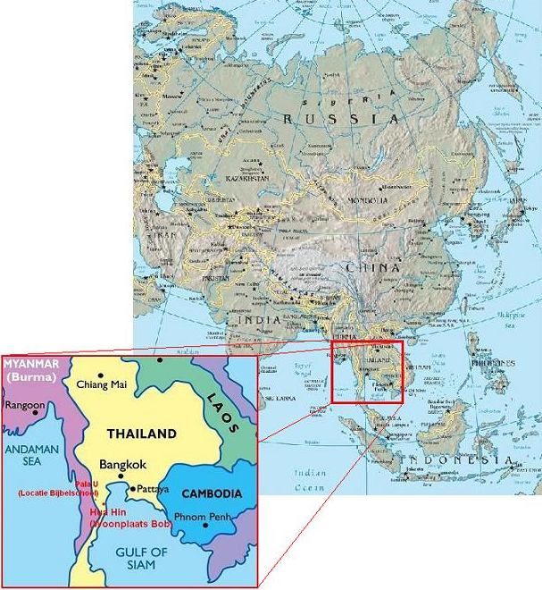
Residence

Bob now lives in Hua Hin, a city 225 km southwest of Bangkok, the capital of Thailand (see map). Bob’s house is on the First mountain in a small village outside Hua Hin. This made that in October 2010 he did not suffer from the extreme rainfall that flooded quarter of the country

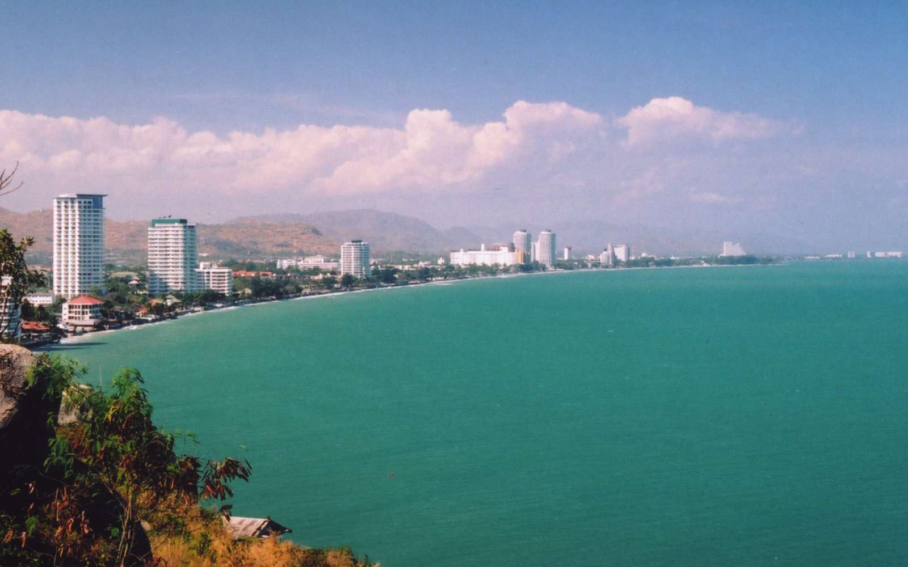

Coast of Hua Hin

News

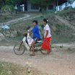
Immigration
There were many aspects to control the immigration, including a Thai driving license for motorcycle and a car to drive in Thailand. Besides, Bob had to rest a lot from the hectic time just before his final departure from The Netherlands. Meanwhile, Bob spent the first months a lot of attention to expanding his social network in his new environment.

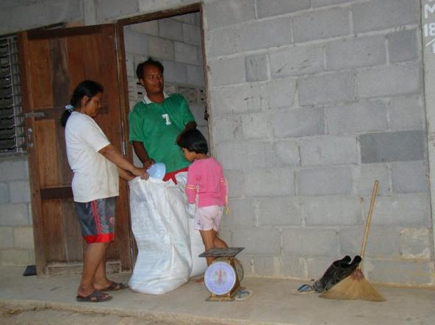
Food project
The Food project that was launched by the family Mulders in 2005 has now been taken over by the Asia Care Foundation. This project runs in Pala U, along the Burmese border, where among others refugees from the Karen tribe live. From the monthly amount of money they receive rice, shrimp paste, salt and oil is purchased. This is distributed by the leaders of the Bible school in Pala U among widows and orphans of the Karen tribe. Each family gets a balanced portion of rice


Thai lesson
Bob started a Thai language lesson in April 2011. First priority is to be able to write and read the language. Speaking will be treated afterwards.
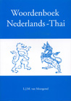

Medications
As worldwide people have chronic illnesses such as chronic obstructive pulmonary, diabetes or high blood pressure, also the people of the Karen have. Some refugees from the Karen have no money to buy these medicine by themselves. For these people, the medicine are partly or wholly bought by the Asia Care Foundation.

Website

Contact

Board
E-mail
info@asiacarefoundation.org
Website:
www.asiacarefoundation.org
Postal adress:
Stichting Asia Care Foundation
Dr. Asjeslaan 35
4003 WS Tiel
The Netherlands
Phone number:
+31(0)344 611362

Bob van Rijn
Postal adress:
P.O. Box 144
Hua Hin
Prachuap Kirikhan 77110
Thailand.
Phone number:
0066 (0) 823481963
E-mail:
bob@asiacarefoundation.org
Skypename:
bobvanrijn1956

Keeping informed
One can (un)subscribe for receiving
the news letter by writing an e-mail
to info@asiacarefoundation.org

€ Support
-Dutch bank account:
5641822 of Asia Care Foundation Tiel (The Netherlands). ING bank Nederland, Bijlmerdreef 109, 1102 BW Amsterdam, The Netherlands. BIC/SWIFT-code: INGBNL2A. IBAN: NL49INGB0005641822

-Thai bank account:
4890100776 of Gijsbertus Hendrikus van Rijn, P.O. Box 144, Hua Hin, Prachuap Kirikhan 77110, Thailand. Krung Thai Bank, 234/1 Petchkasem RD, Hua Hin Prachuap Kirikhan 77110, Thailand, BIC: KRTHTHBK

Board:
Jan Strijker – Chairman
Matthias den Hartog – Scribe
Hans van Schaik – Treasurer

The website of Asia Care Foundation is present at www.asiacarefoundation.org. On this website more information about the work of Bob can be read. One can also found the story of Bob.

Support

You can support Bob’s work in Asia and also himself in various ways:

-By sending him a postcard. The postal adress in Thailand stands besides.
-By praying for him and his work. Topics to pray for will appear on the website.
-By donating a cash amount to one of the following Bank accounts:*

- Bank account 5641822 of Asia Care Foundation Tiel (The Netherlands). ING bank Nederland, Bijlmerdreef 109, 1102 BW Amsterdam, The Netherlands. BIC/SWIFT-code: INGBNL2A. IBAN: NL49INGB0005641822
- Bank account 4890100776 of Gijsbertus Hendrikus van Rijn, P.O. Box 144, Hua Hin Prachuap Kirikhan 77110, Thailand. Krung Thai Bank, 234/1 Petchkasem RD, Hua Hin Prachuap Kirikhan 77110, Thailand, BIC: KRTHTHBK

Money coming into these accounts will be used among other for the purposes specified in this letter. Thanks in advance for your support.

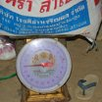
Sincerely,

Bob, Jan, Hans en Matthias
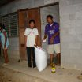

*The dutch bank account is controlled by the board of Asia Care Foundation and the Thai banking account is controlled by Bob and checked by the board of Asia Care Foundation. From donations of donors outside the euro-zone a lower part of the money is lost by the rates of exchanges if they directly send the money in Thai Bath to the Thai Bank account.

